

CAPSTONE PROJECT REPORT
Report 3 – Software Requirement Specification

– Ho Chi Minh, May 2026 –
Table of Contents
I. Record of Changes 3
II. Software Requirement Specification 4
1. Product Overview 4
1.1 Context Diagram 4
1.2 Main Workflows 6
1.3 User Requirements 9
1.4 System Functionalities 21
1.5 Entity Relationship Diagram [TEAM] 26
2. Use Case Specifications 26
2.1 Authentication [HIỀN] 26
2.2 Profile Management 31
2.3 HR Question Generation 33
2.4 Question Set Management 39
2.5 Marketplace and Practice Management 46
2.6 AI Evaluation and Feedback Management [NAM] 59
2.7 Knowledge Base Management [NAM] 62
2.8 RAG Evaluation Management [NAM] 66
2.9 Subscription and Payment Management 68
2.10 Admin Management 68
3. Functional Requirements 71
3.1 System Functional Overview 71
3.2 Job Seeker / Candidate 76
3.4 System Administrator 84
3.5 AI/RAG Processing 86
4. Non-Functional Requirements 90
4.1 External Interfaces 90
4.2 Quality Attributes 94
5. Requirement Appendix [HIỀN + KHOA] 97
5.1 Business Rules [HIỀN] 97
5.2 Common Requirements [HIỀN] 98
5.3 System Messages List [KHOA] 99

I. Record of Changes
Date | A*  M, D | In charge | Change Description
*A - Added M - Modified D - Deleted

II. Software Requirement Specification

1. Product Overview

IQGS (Interview Question Generation System) is an AI-powered dual-sided web platform that automates the creation and delivery of technical interview question sets using Retrieval-Augmented Generation (RAG) and Large Language Models (LLMs). The system is designed to solve a critical pain point in the IT hiring industry: the time-consuming and inconsistent process of manually crafting role-specific interview questions.
On the HR Manager / Recruiter side, the system allows users to input or upload a job description (JD) in PDF, DOCX, or plain text format. The platform then processes the JD through a RAG pipeline — extracting and embedding the JD content, retrieving semantically relevant context from a curated Knowledge Base sourced from SWEBOK, ACM/IEEE Computing Curricula, Tech Interview Handbook, and System Design Primer, constructing a structured prompt, and invoking a configurable production LLM to generate role-specific, difficulty-tiered interview questions. The selected LLM can be changed based on cost, quality, latency, and provider availability without changing the core RAG workflow.
The generated questions are presented for HR review, editing, and organization into named question sets. Approved sets can be published to the platform marketplace, making them visible to job seekers.
On the Job Seeker / Candidate side, users can browse and search the public marketplace of published question sets by company, skill domain, or difficulty tier. Candidates can initiate timed practice sessions, submit text-based answers, and receive detailed AI-generated feedback powered by the same configurable LLM service. The feedback evaluates each answer for relevance, technical correctness, and clarity, providing actionable suggestions for improvement. Candidates may also share their practice scorecard directly with the hiring company's HR inbox.
The platform operates on a freemium subscription model: HR Managers pay for AI generation quota, while candidates access a free tier with limited question visibility and a premium tier for full access and advanced evaluation.

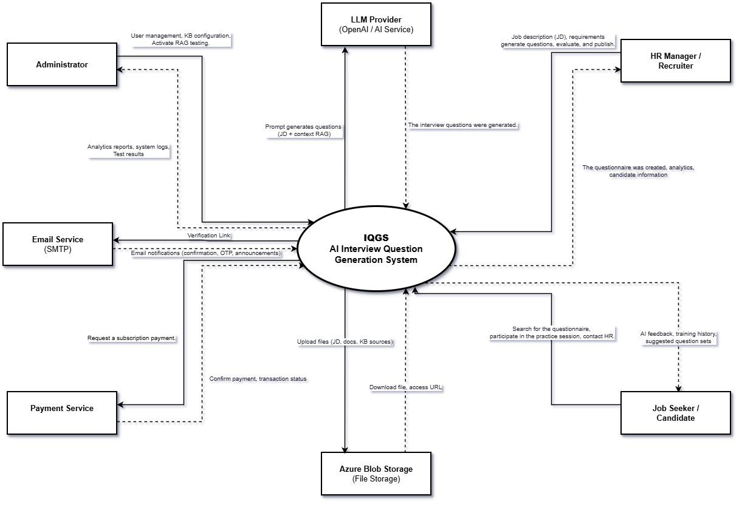
Figure 1: Context Diagram (Link)

2. User Requirements

2.1 Actors
The IQGS platform interacts with nine actors: four human actors and five external systems or services.
 | Actor | Description
1 | Guest | An unauthenticated visitor who can view the landing page, browse subscription plan pricing, register as Job Seeker or HR Manager, and initiate the login/forgot-password flow. Guests cannot access the marketplace, generate questions, or start practice sessions.
2 | Job Seeker / Candidate | An authenticated user with the Candidate role. Can browse and search the public question set marketplace, start timed practice sessions, submit answers, view AI-generated feedback, track practice history, send contact requests to HR Managers with practice scorecards, and manage their subscription plan.
3 | HR Manager / Recruiter | An authenticated user with the HR Manager role whose account has been approved by an Administrator (LI-02). Can input or upload job descriptions, configure and trigger AI question generation (RAG pipeline), review and edit generated questions, create and publish question sets, view recruitment analytics, manage candidate contact requests, and manage subscription plan.
4 | Administrator | An authenticated super-user with full platform access. Manages all user accounts, the Knowledge Base, subscription plan configurations, RAG baseline evaluation experiments (mandatory per project topic §3.3), and system configuration parameters.

2.2 Use Cases

2.2.1 Diagrams (Vẽ lại tất cả actor chung 1 diagram)
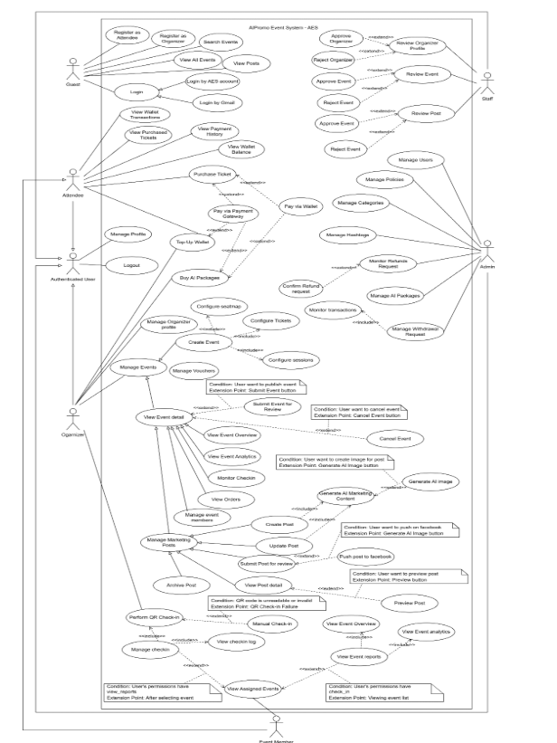

2.2.2 Descriptions (Làm lại theo use case diagram mới )
UC ID | Use Case Name | Actors | Description
UC-G01 | View Home Page | Guest | Guest views the IQGS public landing page with platform description, features overview, and pricing tier summary.
UC-G02 | View Subscription Plans | Guest | Guest views all active subscription tiers, included features, and pricing before registering.
UC-G03 | Register as Job Seeker | Guest, Email Service | Guest creates a Job Seeker account; system sends email verification link.
UC-G04 | Register as HR Manager | Guest, Email Service | Guest creates an HR Manager account (Status = Pending until Admin approval per LI-02); system sends verification email.
UC-G05 | Login | Guest | Guest submits email and password credentials to authenticate and obtain a JWT access token.
UC-G06 | Forgot Password | Guest, Email Service | Guest requests a password reset link sent to their registered email (anti-enumeration: identical response regardless of email existence).
UC-A01 | Verify Email | All Roles, Email Service | User clicks verification link to activate account (IsEmailVerified = true).
UC-A02 | Reset Password | All Roles | User sets a new password using a valid, unexpired, single-use reset token.
UC-A03 | Logout | All Roles | User ends session; refresh token invalidated server-side.
UC-A04 | Update Profile | All Roles | User updates personal info and avatar; HR Manager updates company details.
UC-A05 | Change Password | All Roles | User changes password after verifying current password.
UC-HR01 | Input Job Description | HR Manager | HR Manager types or uploads a JD file (PDF/DOCX/TXT) for question generation.
UC-HR02 | Configure Generation | HR Manager | HR Manager sets seniority, question count, question types, and tech stack tags.
UC-HR03 | Generate Questions | HR Manager, LLM Service | HR Manager triggers async RAG pipeline; system generates structured questions.
UC-HR04 | View Generated Questions | HR Manager | HR Manager views the AI-generated question list after job completes.
UC-HR05 | Edit Generated Questions | HR Manager | HR Manager edits question text, difficulty, or sample answers inline.
UC-HR06 | Save to Question Set | HR Manager | HR Manager saves selected questions to a new or existing question set.
UC-HR07 | Manage Question Sets | HR Manager | HR Manager views, searches, edits, and deletes their own question sets.
UC-HR08 | Publish Question Set | HR Manager | HR Manager changes a set's visibility to Public for the marketplace.
UC-HR09 | Unpublish Question Set | HR Manager | HR Manager reverts a public set to Private/Draft status.
UC-HR10 | Export Question Set | HR Manager | HR Manager downloads a question set as PDF or DOCX.
UC-HR11 | View Recruitment Analytics | HR Manager | HR Manager views charts on question set usage: attempts, completion rates, and scores.
UC-HR12 | Manage Contact Inbox | HR Manager | HR Manager views, accepts, or declines candidate contact requests.
UC-HR13 | View Generation History | HR Manager | HR Manager reviews past generation jobs with status and output.
UC-HR14 | Cancel Generation Job | HR Manager | HR Manager cancels a queued or running generation job.
UC-JS01 | Browse Question Sets | Job Seeker | Job Seeker browses the paginated public marketplace of published question sets.
UC-JS02 | Search and Filter Sets | Job Seeker | Job Seeker filters sets by role, tech stack, company, seniority, or difficulty.
UC-JS03 | View Question Set Detail | Job Seeker | Job Seeker views set details: skills, difficulty, publisher, and aggregate statistics.
UC-JS04 | Bookmark Question Set | Job Seeker | Job Seeker toggles a bookmark on a question set for later access.
UC-JS05 | Start Practice Session | Job Seeker | Job Seeker initiates a timed practice session for a selected question set.
UC-JS06 | Submit Answers | Job Seeker, LLM Service | Job Seeker submits answers; LLM evaluates and generates AI feedback asynchronously.
UC-JS07 | View AI Feedback | Job Seeker | Job Seeker views per-answer feedback: score, strengths, and missing points.
UC-JS08 | View Interview Summary | Job Seeker | Job Seeker views the overall session performance summary with aggregated scores.
UC-JS09 | View Practice History | Job Seeker | Job Seeker views past sessions, scores, and progress over time.
UC-JS10 | Contact HR | Job Seeker, Email Service | Job Seeker sends a contact request to HR with a practice scorecard attached.
UC-P01 | View Subscription Plans | HR Manager, Job Seeker | User views all active plan tiers, pricing, and feature comparison.
UC-P02 | Upgrade Subscription | HR Manager, Job Seeker | User selects a higher plan and initiates the payment flow (Order + VietQR).
UC-P03 | Verify Payment | System, Payment Service | System receives payment callback, verifies transaction, and activates subscription.
UC-P04 | View Transaction History | HR Manager, Job Seeker | User views paginated past Orders with dates, amounts, and plan details.
UC-P05 | Enforce Feature Access | System (middleware) | System validates subscription tier and quota before granting access to premium features.
UC-AD01 | Manage Users | Administrator | Admin views, activates, suspends, or changes roles of user accounts.
UC-AD02 | Manage Knowledge Base | Administrator, File Storage | Admin uploads, re-ingests, or deletes knowledge base documents.
UC-AD03 | View Ingestion Status | Administrator | Admin monitors ingestion pipeline status per knowledge base document.
UC-AD04 | Trigger RAG Evaluation | Administrator, LLM Service | Admin triggers RAG vs. zero-shot vs. few-shot comparison experiment (mandatory per project topic §3.3).
UC-AD05 | View Evaluation Report | Administrator | Admin views and exports RAG baseline evaluation results.
UC-AD06 | Moderate Content | Administrator | Admin reviews and removes violating public question sets from the marketplace.
UC-AD07 | View System Analytics | Administrator | Admin views system metrics: users, generation jobs, token usage, and uptime.
UC-AD08 | Manage Subscription Plans | Administrator | Admin creates, updates, or deactivates subscription plan configurations.
UC-AD09 | Manage System Config | Administrator | Admin updates platform-wide configuration (API keys, Top-K value, similarity thresholds).

3.Functional Requirements

3.1 System Functional Overview

3.1.1 Screens Flow

3.1.2 Screen Descriptions

3.1.3 Screen Authorization

3.1.4 Non-Screen Functions

3.1.5 Entity Relationship Diagram

3.2 Web Application

3.2.1 HR Manager Interface

3.2.2 Candidate Interface
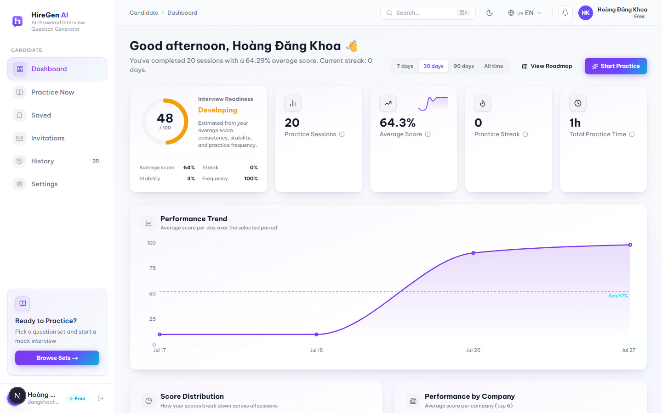
Figure 3.2.2.1. Candidate Dashboard, loaded state with real account data.

3.2.2.1 Candidate Dashboard

Function trigger:
Shown right after a Candidate logs in. Candidates can also get back to it any time by clicking “Dashboard” in the sidebar.
Function description:
This is the candidate's home page. It pulls together past practice sessions, AI scores and a few recommendations so the candidate has one place to check how their interview prep is going.
Pre-condition:
- The candidate is logged in.
- Each widget loads on its own and can be in a loading, error or empty state independently — for example the score-distribution or skill-radar charts stay empty until there is enough AI-scored practice data to draw them.
Function detail:
- Time range filter with options 7 days, 30 days, 90 days and All time. Switching it recalculates every KPI and chart below.
- KPI row shows Interview Readiness (a 0–100 score with a label like “Developing”), Practice Sessions, Average Score, Practice Streak and Total Practice Time.
- A Performance Trend chart plots average score per day for the selected range against the candidate's overall average.
- Score Distribution, Performance by Company, Skill Radar, Practice Heatmap, Weekly Goal and Role Readiness widgets only render once there is enough AI-scored data; before that they show a short guidance message instead of an empty chart.
- An AI Career Coach panel gives a short recommendation based on recent scores and weak skills, with a “View Roadmap” link.
- The Recent Practice list lets the candidate reopen a past session's feedback or retry the same set.
- Recommended Question Sets can be bookmarked straight from the dashboard card.
- The “Start Practice” button at the top of the page jumps straight to the marketplace.

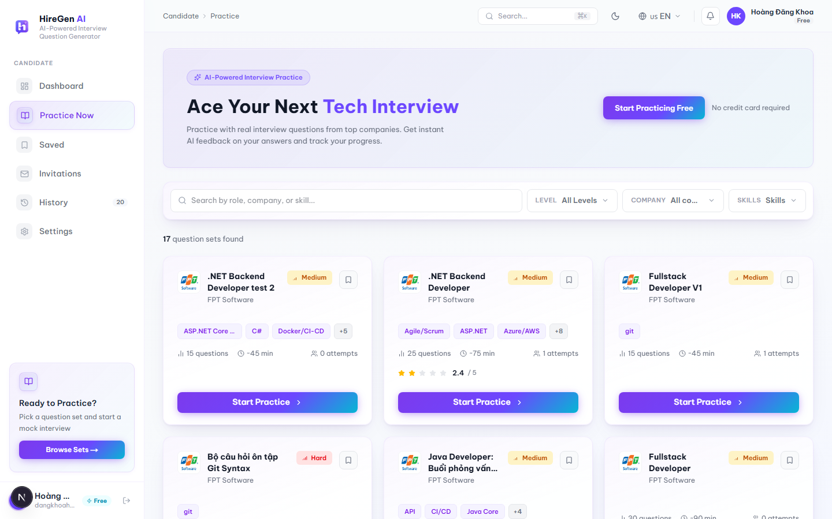
Figure 3.2.2.2. Practice Now / Question Set Marketplace, 17 published sets.

3.2.2.2 Question Set Marketplace (Practice Now)

Function trigger:
Candidate clicks “Practice Now” in the sidebar, or “Browse Sets” / “Start Practice” on the Dashboard.
Function description:
Where candidates browse and filter the published question sets to find one worth practicing with.
Pre-condition:
- Candidate is authenticated.
- At least one question set must already be published, otherwise the list has nothing to show.
Function detail:
- Search box (400 ms debounce) is meant to match role, company or skill. In practice the backend keyword filter only matches the set title, so the client pulls a larger page of results and also matches company name and skills locally — otherwise searching by company wouldn't work at all.
- Filters for Difficulty (single-select), Company (single-select with its own search box) and Skills (multi-select with search and a “Clear all” button) are available; changing any of them resets the list back to page 1.
- Each card shows the company logo/name, difficulty pill, question count, estimated time, how many attempts it's had, average rating if there is one, up to 3 skill tags plus a “+N” overflow, and a bookmark icon.
- Pagination is done with numbered page buttons (9 sets per page), not infinite scroll.
- Loading, error-with-retry and empty (no matching set) states are all handled.
- Clicking a card's title or its “Start Practice” button opens the Question Set Detail page.

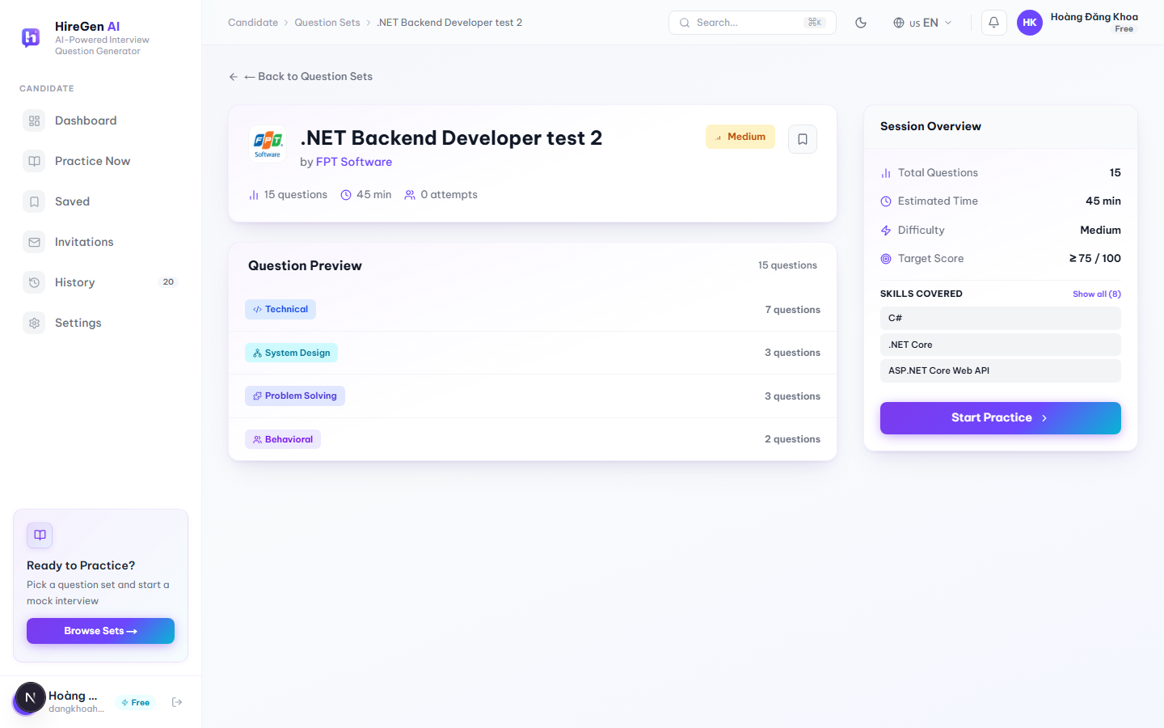
Figure 3.2.2.3. Question Set Detail page.

3.2.2.3 Question Set Detail

Function trigger:
Reached by opening a set from the Marketplace, the Dashboard, Saved Sets, an interview invitation, or “Retry” in History.
Function description:
Shows what a candidate needs before deciding to start the mock interview: difficulty, target score, question mix and so on.
Pre-condition:
- Candidate is authenticated.
- The set exists and is published.
Function detail:
- The header has the company logo, the set title, a “by [Company]” link that opens the Company Info Modal, a difficulty pill and a bookmark toggle.
- A Question Preview lists the question categories actually present in the set (Technical, System Design, Problem Solving, Behavioral, etc. — not a fixed 3-value list) with a count per category.
- The Session Overview card on the right shows Total Questions, Estimated Time, Difficulty and a fixed Target Score of “≥ 75 / 100”, plus the set's skills (first 3 shown, “Show all (N)” to expand).
- The main call-to-action reads “Start Practice” when there's no active attempt, or “Continue” once an IN_PROGRESS session already exists for this set.
- A “Start New” button only appears when there's an in-progress session; it asks for confirmation before it abandons that attempt and starts a fresh one.

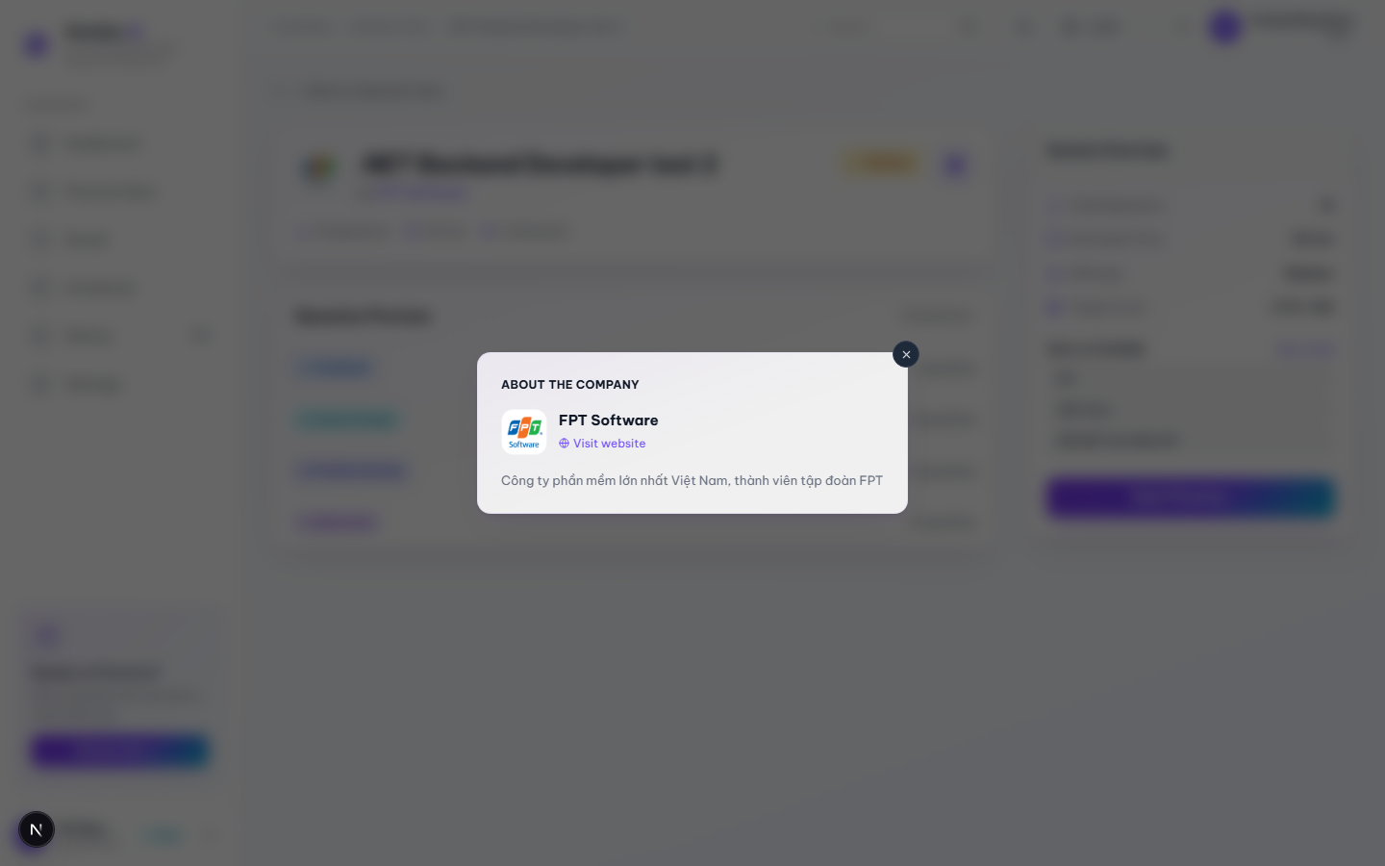
Figure 3.2.2.4. Company Info Modal opened from Question Set Detail.

3.2.2.4 Company Info Modal

Function trigger:
Candidate clicks the company name link on the Question Set Detail page.
Function description:
A quick look at the hiring company without leaving the set detail page.
Pre-condition:
- The selected question set has a company profile attached.
Function detail:
- Shows the company logo, name, a “Visit website” link if one exists, and a short description.
- Any field with no data (e.g. no description) is just left out — there's no empty placeholder text.
- Can be closed with the × button or by clicking the dark area outside the card. Note it does not close on Esc, unlike the Upgrade to Premium modal.

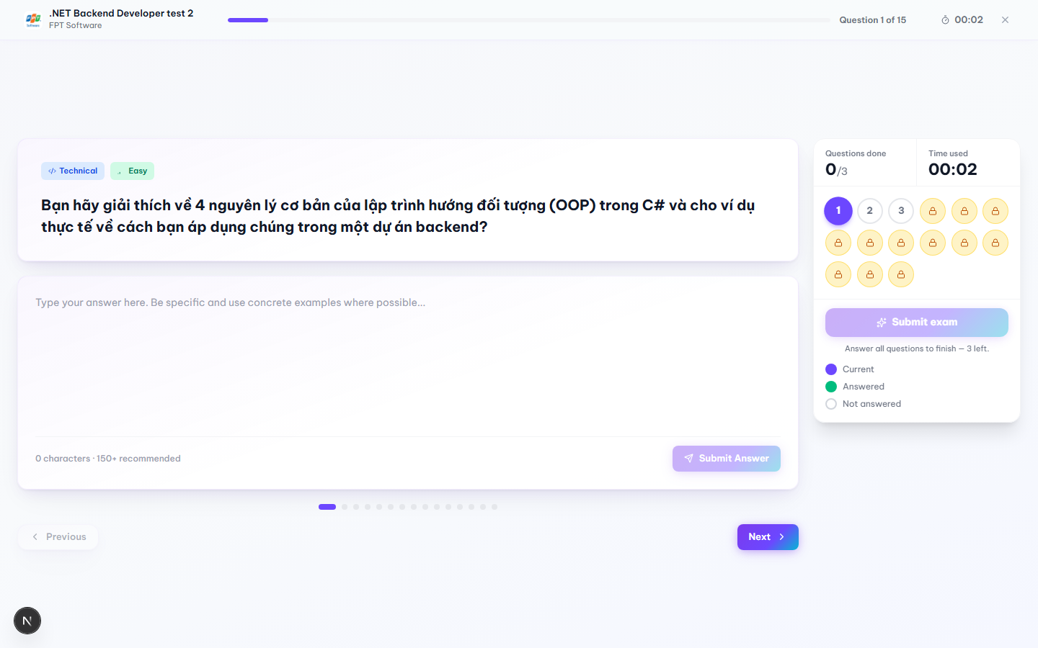
Figure 3.2.2.5a. Practice Session, answering an unlocked question.
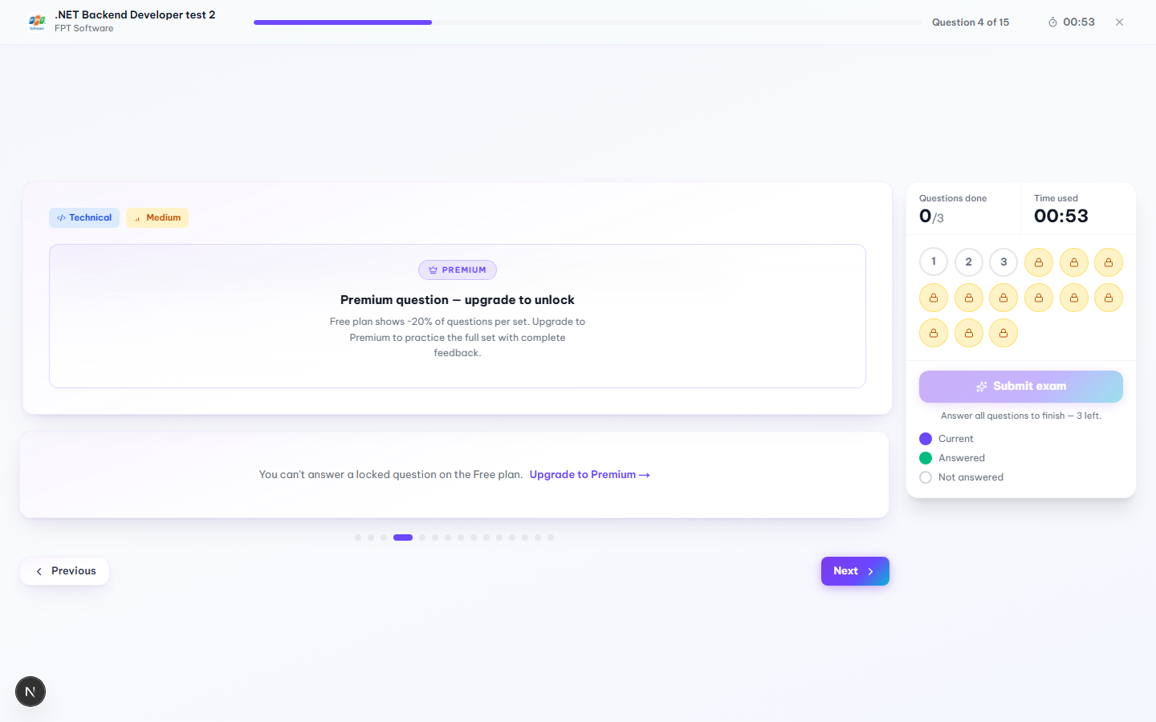
Figure 3.2.2.5b. Free-plan question locking inside an active session; the actual in-app text reads “Free plan shows ~20% of questions per set.”

3.2.2.5 Practice Session (Mock Interview)

Function trigger:
“Start Practice” / “Continue” on the Question Set Detail page, or “Retry” / “Practice Again” from Dashboard, History, Saved Sets or the Feedback page.
Function description:
This is where the actual mock interview happens — one question at a time, free-text answers, and each answer gets AI-scored right after it's submitted.
Pre-condition:
- Candidate is authenticated and allowed to access the selected set.
- The Free-plan practice-attempt quota hasn't been used up (if it has, the backend returns 403 and the candidate sees a “start forbidden” screen instead of the session).
- A new session is started, or an existing IN_PROGRESS one is resumed, successfully.
Function detail:
- Opening the page either starts a new session or silently resumes an unfinished one. When it resumes, a “Resumed” badge shows up, a toast confirms it, and previously submitted answers are already filled in.
- Free-plan accounts only get a portion of a set's questions unlocked — in the set tested, 3 out of 15 (about 20%), matching the real message shown in the app. Locked questions appear blurred with a “Premium” badge and an “Upgrade to Premium” button; clicking it opens the Upgrade modal without losing session progress. The answer box on a locked question is replaced with “You can't answer a locked question on the Free plan.”
- “Submit Answer” stays disabled while the box is empty. On submit, the answer needs at least 20 characters and 3 words — otherwise the message “Answer too short — please write at least 20 characters.” appears and the submission is blocked.
- Typed answers are auto-saved to the browser's session storage as the candidate types. The UI shows “Saving draft…” about 600 ms after the last keystroke, then “Draft saved” for roughly 2 seconds. If the page gets reloaded, an unsubmitted draft comes back automatically.
- After a valid submit the answer goes off for AI scoring and the box shows “AI is evaluating your answer…”. Once scored, the question turns green and the session moves to the next question after about 600 ms.
- A question grid on the right shows every question's state — current, answered, unanswered or locked — and the candidate can jump to any unlocked one directly. Previous/Next buttons step through in order.
- For timed sets there's a countdown based on the session's absolute expiry time from the backend; it turns red under 5 minutes left and stays accurate even if the tab loses focus, since it re-syncs when the tab becomes visible again. Untimed sets show elapsed time instead.
- If the countdown hits zero, the session is force-submitted right away and the candidate is sent to the result page — the review dialog is skipped in that case.
- “Finish & Get Feedback” only becomes clickable once every unlocked question has an answer. Confirming the dialog in §3.2.2.7 finishes the session and sends the candidate to the AI Feedback page.
- If there's unsaved typed text in the answer box, closing or refreshing the tab triggers the browser's native “leave site?” warning.

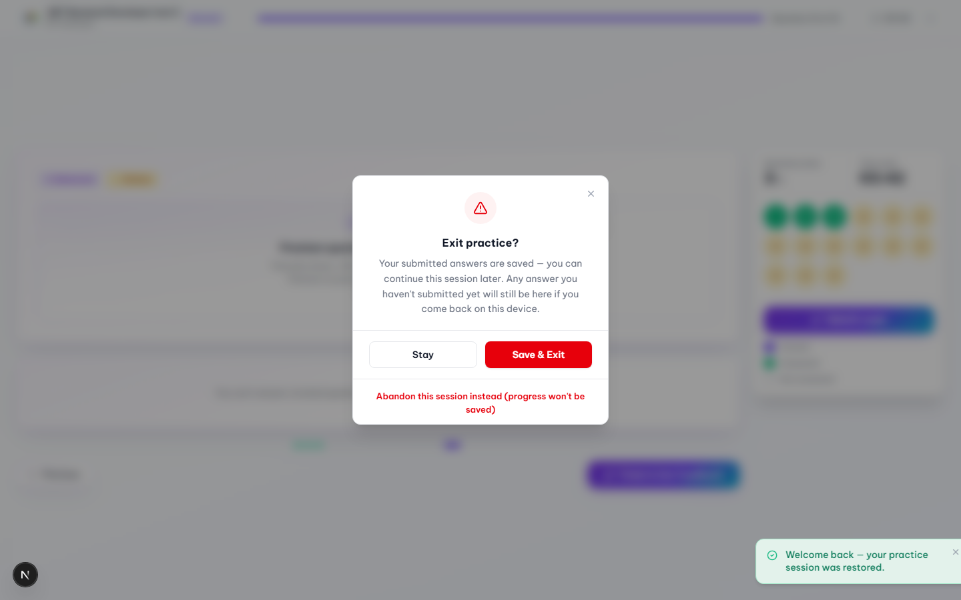
Figure 3.2.2.6. Exit practice confirmation dialog.

3.2.2.6 Exit Practice Confirmation Dialog

Function trigger:
Candidate clicks the × icon in the header of an active practice session.
Function description:
A safety step before leaving a mock interview midway, so the candidate doesn't accidentally lose an attempt.
Pre-condition:
- A practice session is currently in progress.
Function detail:
- Stay just closes the dialog and keeps the candidate on the current question. Nothing changes.
- Save & Exit leaves the page right away. Answers already submitted stay saved, so the candidate can pick the session back up later, either from this device or via “Continue” on the set detail page.
- Abandon this session instead is a smaller text link below the two main buttons. It permanently cancels the attempt — status becomes ABANDONED and unsaved progress is thrown away — so a fresh attempt can be started right after.

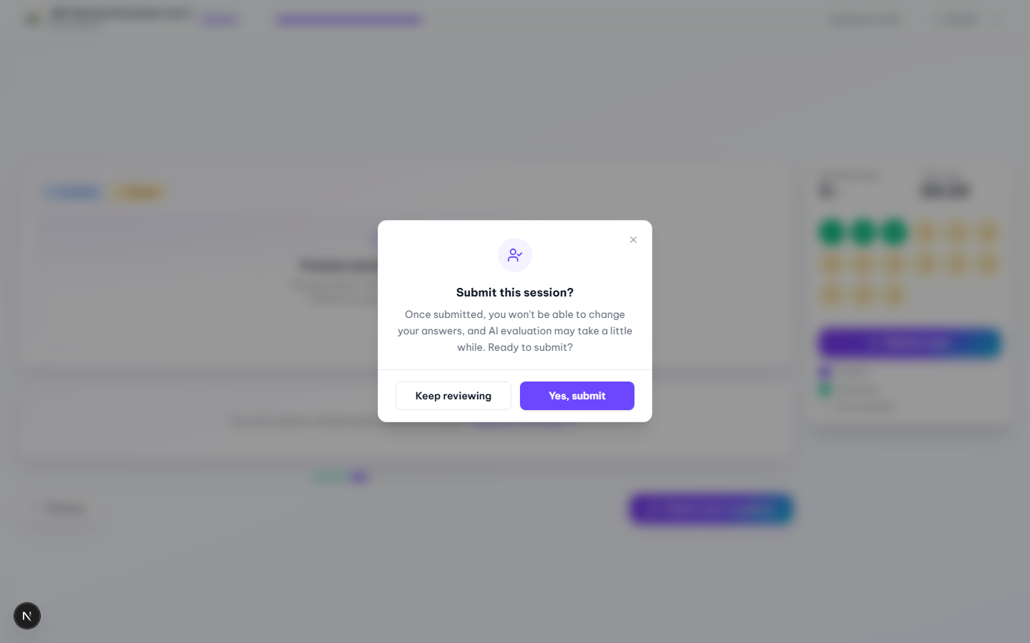
Figure 3.2.2.7. Submit-session confirmation dialog, shown once every unlocked question has an answer.

3.2.2.7 Submit Session Confirmation Dialog

Function trigger:
Candidate clicks “Finish & Get Feedback” (or “Submit exam” in the sidebar) after answering every unlocked question.
Function description:
One last check before answers are locked in, since nothing can be edited once the session is submitted.
Pre-condition:
- Every unlocked question in the session already has a submitted answer.
Function detail:
- The dialog text warns that answers can't be changed afterward and that AI evaluation may take a moment.
- Keep reviewing closes the dialog and leaves the session as it is.
- Yes, submit finishes the session and takes the candidate to the AI Feedback & Result page.

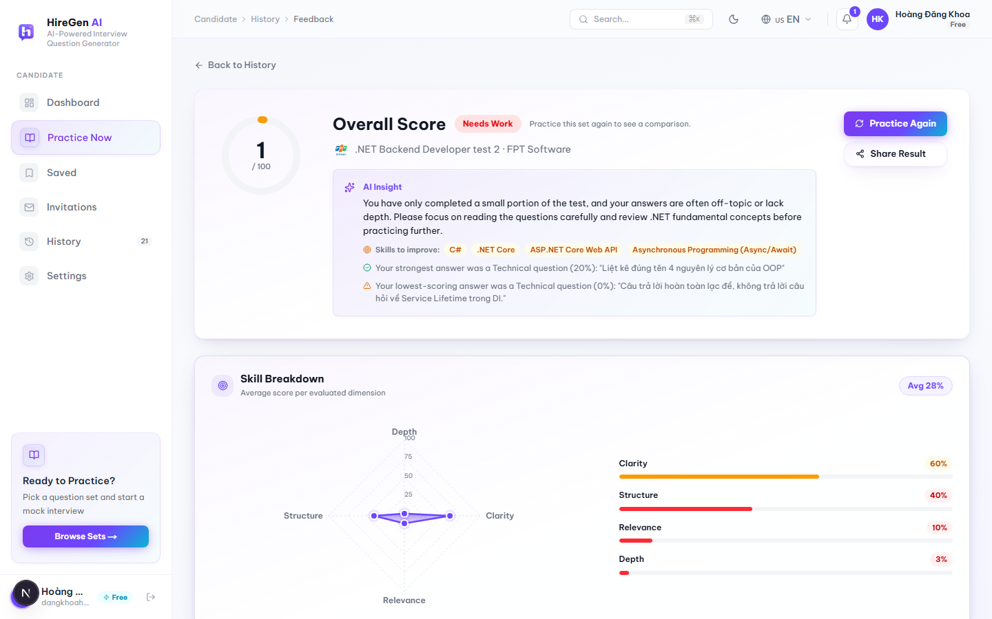
Figure 3.2.2.8a. AI Feedback & Result Report: overall score, AI Insight, Skill Breakdown.
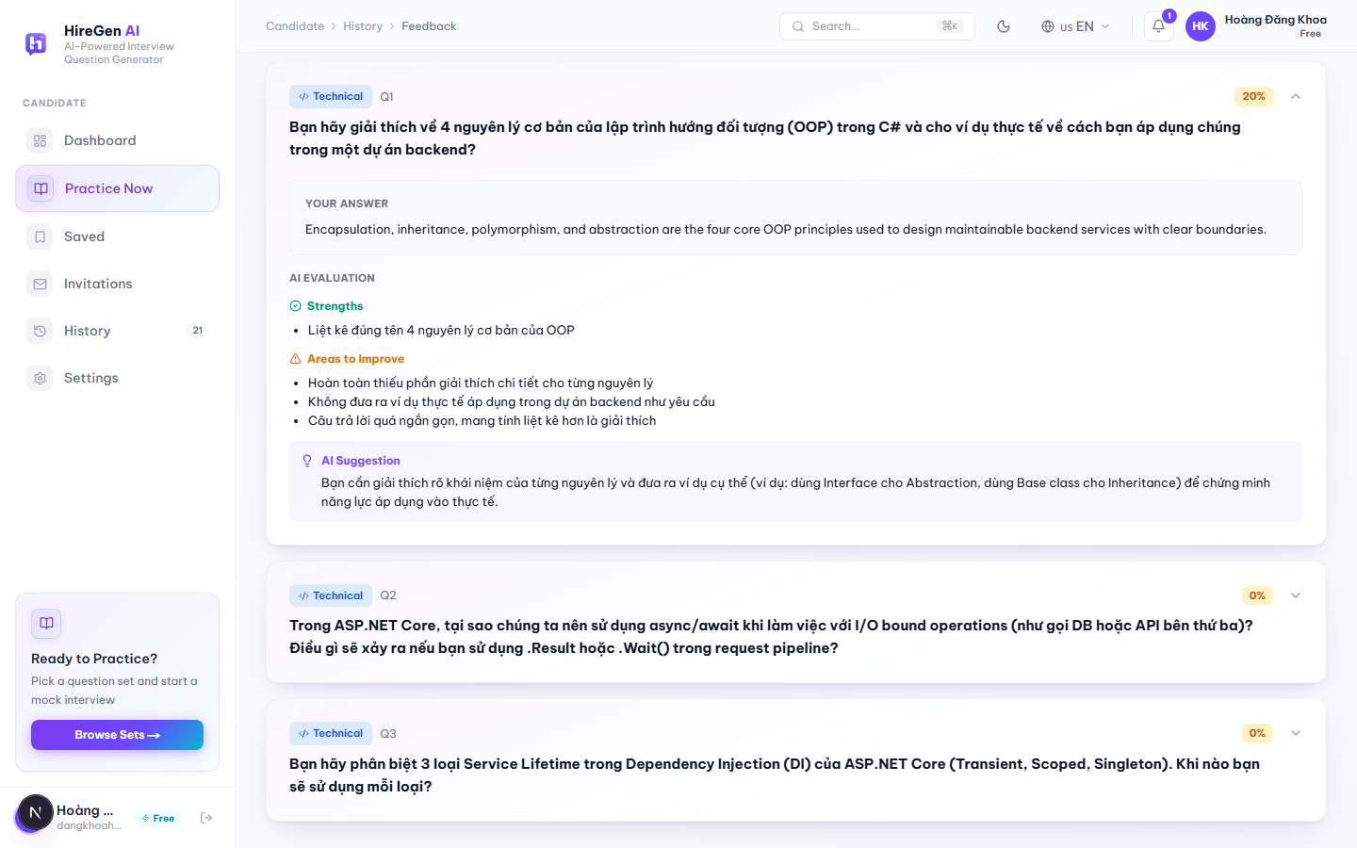
Figure 3.2.2.8b. Question-by-Question Review, with Strengths, Areas to Improve and an AI Suggestion.

3.2.2.8 AI Feedback & Result Report

Function trigger:
Opens automatically right after a session finishes (or auto-submits), or via “View” from the Dashboard, Practice History, or a shared result link.
Function description:
The full AI write-up for one completed mock interview.
Pre-condition:
- The session status is COMPLETED.
- Route: /jobseeker/practice/[sessionId]/result.
Function detail:
- An Overall Score (0–100) is shown with a label such as “Needs Work”. On a first attempt it says “Practice this set again to see a comparison”; on later attempts it compares the score against the previous one.
- AI Insight gives a short write-up plus “Skills to improve” tags, and calls out the single strongest and single weakest answer with a quoted excerpt from each.
- Skill Breakdown is a radar chart plus bars for Clarity, Structure, Relevance and Depth with an average badge; it only shows up once there's real scoring data — no numbers are made up to fill the chart.
- Action Plan lists up to 3 improvement suggestions, built from the weakest-scoring answers.
- Question-by-Question Review lets each question expand or collapse (the first one is open by default), showing the candidate's answer plus AI-identified strengths, areas to improve, and a suggestion.
- “Practice Again” starts a new session on the same set; “Share Result” copies the result link to the clipboard.
- If the score isn't ready yet, the rest of the page still shows normally while it quietly polls every 3 seconds, up to 8 tries, before giving up.
- A small celebration animation plays when the score is 80 or above.

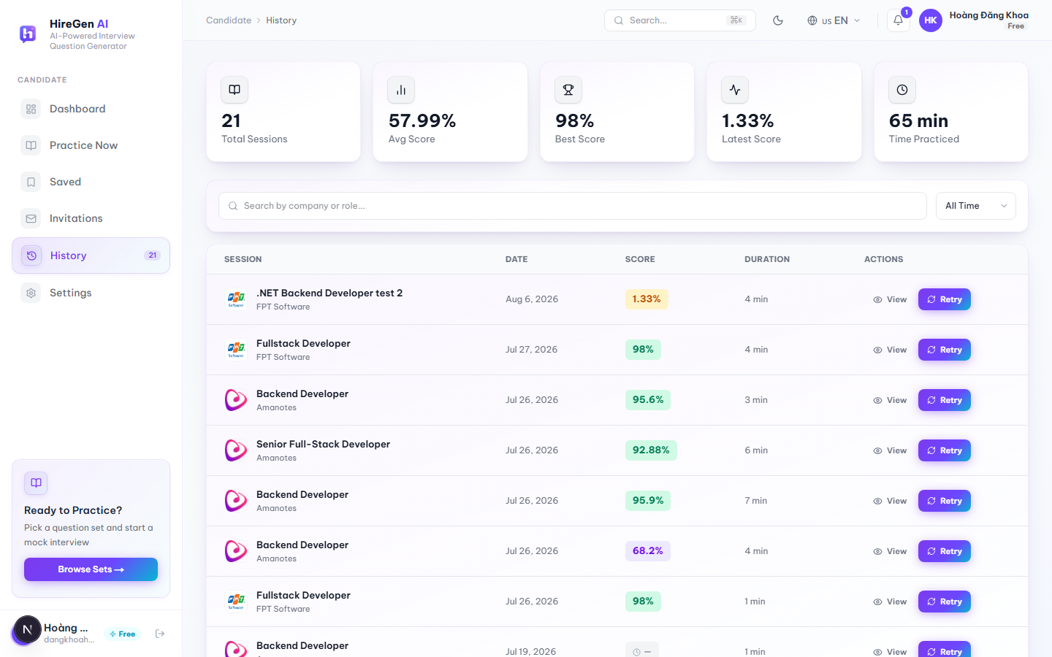
Figure 3.2.2.9. Practice History, 21 completed sessions.

3.2.2.9 Practice History

Function trigger:
Candidate clicks “History” in the sidebar.
Function description:
A record of every completed mock interview, with a way back into each one's AI feedback.
Pre-condition:
- Candidate is authenticated.
- An empty state is shown instead of the table if there are no completed sessions yet.
Function detail:
- Summary numbers at the top: Total Sessions, Average Score, Best Score, Latest Score, Total Time Practiced.
- There's a search box (350 ms debounce) by company or role, and a time filter — All Time, This Week, This Month.
- The table itself lists company/role, completion date, AI score (color-coded, or a pending indicator if scoring is still running), duration, and “View” / “Retry” actions per row.
- Sessions load 20 at a time; on mobile the table becomes a stack of cards instead.

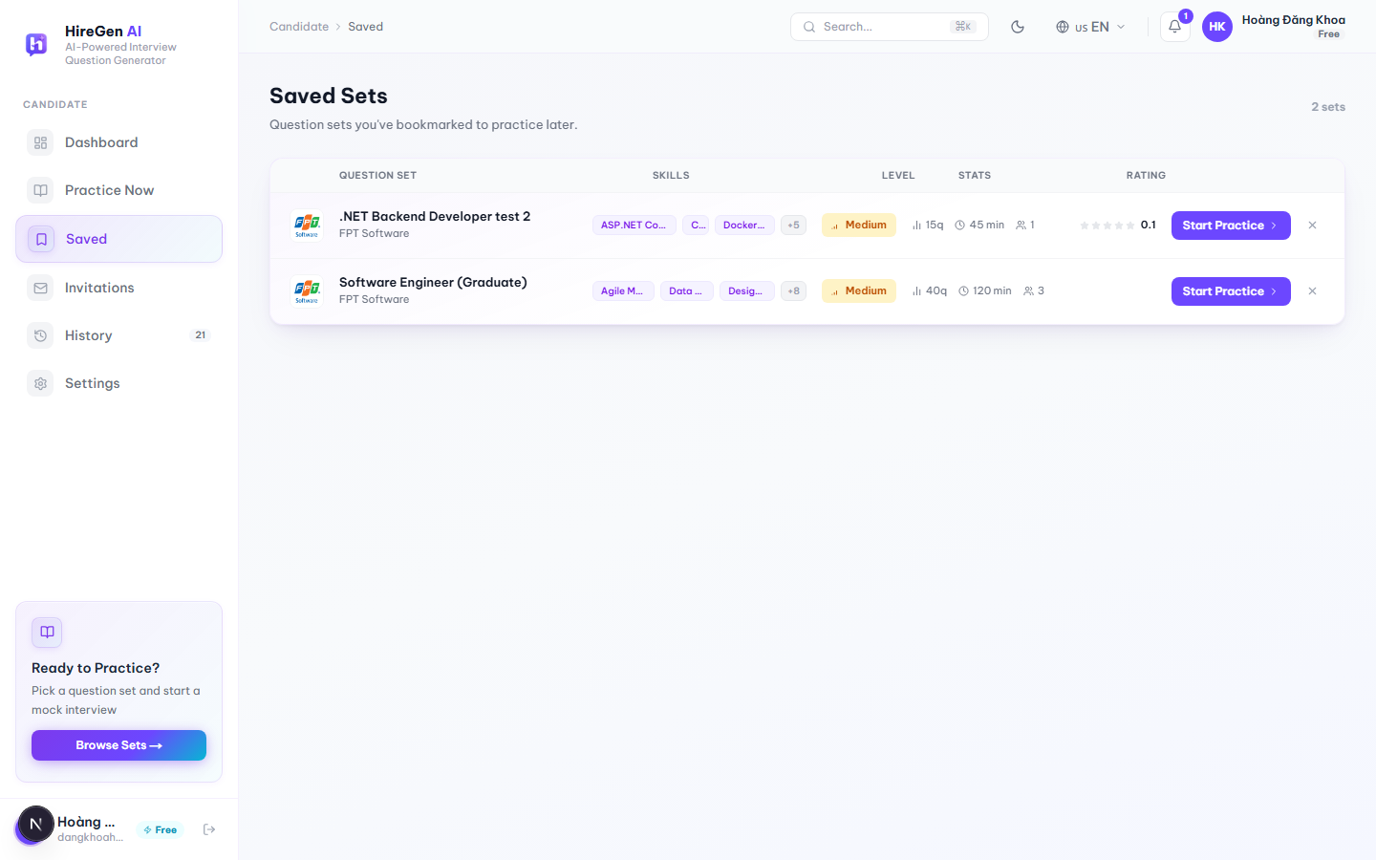
Figure 3.2.2.10. Saved Sets page.

3.2.2.10 Saved Sets (Bookmarks)

Function trigger:
Candidate clicks “Saved” in the sidebar, or the bookmark icon on any question-set card (Marketplace, Dashboard, Question Set Detail).
Function description:
A short list of question sets the candidate wants to come back to.
Pre-condition:
- Candidate is authenticated.
- If nothing has been bookmarked yet, an empty state with a hint is shown instead of the table.
Function detail:
- The table lists each saved set with its skills, difficulty, question count / estimated time / attempts, and rating.
- “Start Practice” launches that set's session right from the row.
- An × button removes the bookmark; the row disappears right away and a toast confirms it.
- Bookmark state is kept in sync everywhere — Marketplace, Dashboard, Question Set Detail and this page.

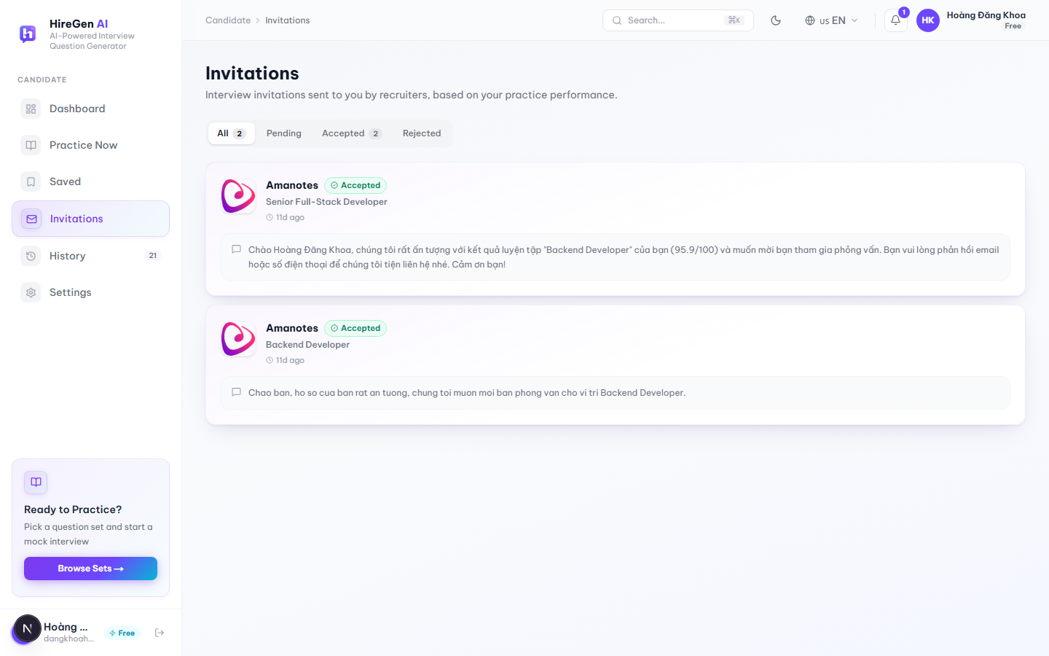
Figure 3.2.2.11. Interview Invitations page.

3.2.2.11 Interview Invitations

Function trigger:
Candidate clicks “Invitations” in the sidebar.
Function description:
Where recruiters' interview invitations show up, based on how the candidate has been performing in practice.
Pre-condition:
- Candidate is authenticated.
- An empty state is shown if there are no invitations.
Function detail:
- Status tabs — All, Pending, Accepted, Rejected — each with a live count.
- Each card shows the company logo/name, status, the recruiter's message, and how long ago it arrived.
- “Accept” isn't instant — it opens a small modal where the candidate can optionally add a message and a phone number (must be 10 digits, starting with 0) before confirming.
- “Decline” opens a confirmation dialog first (“Decline this invitation? … The recruiter will see that you declined.”) before the status flips to Rejected.
- If the invitation was already answered elsewhere — another tab or device, say — the app shows “You've already responded to this invitation.” instead of a generic error.

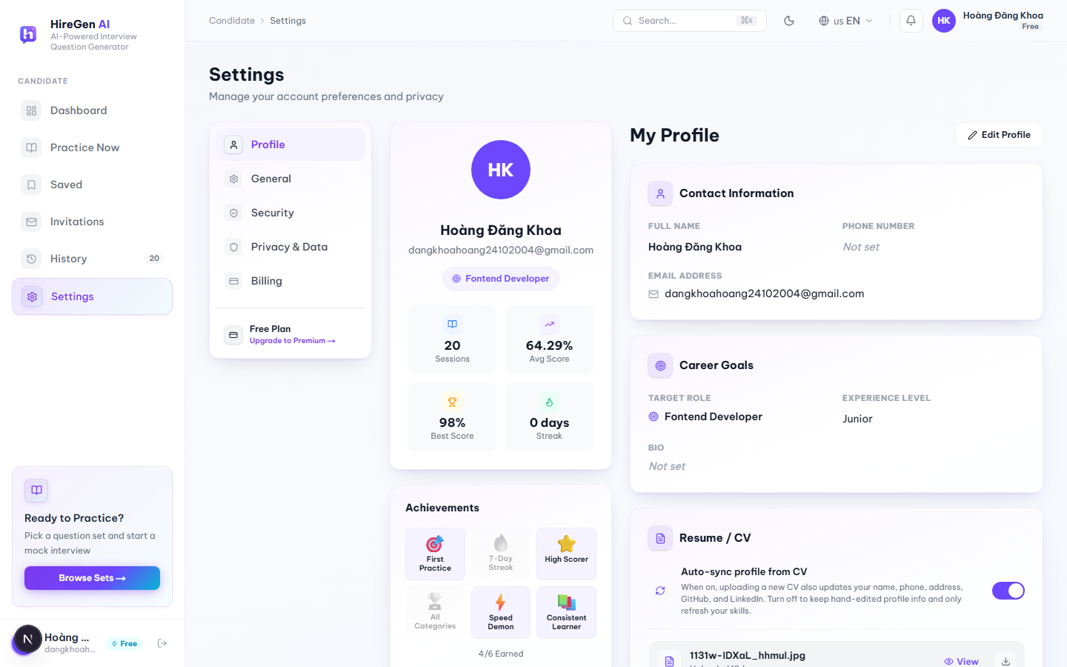
Figure 3.2.2.12a. Candidate Profile, view mode (Settings → Profile tab).
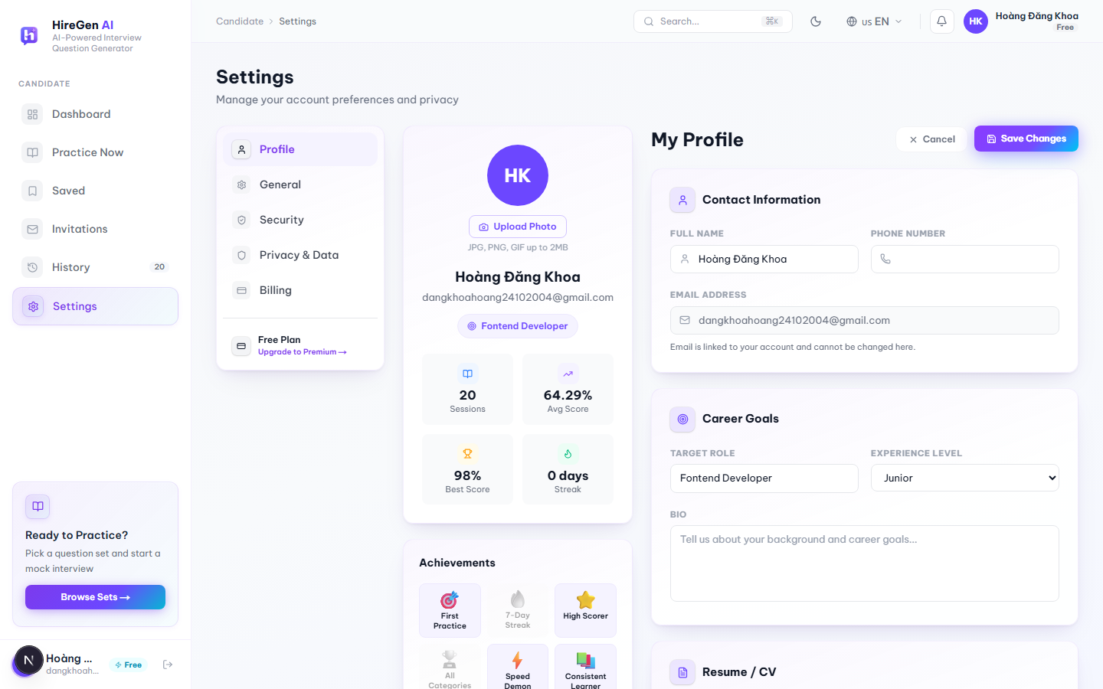
Figure 3.2.2.12b. Candidate Profile, edit mode.

3.2.2.12 Candidate Profile

Function trigger:
Candidate clicks “Settings” in the sidebar (Profile is the first tab, shown by default), or goes directly to /jobseeker/profile.
Function description:
Where a candidate keeps their personal info, career goals and CV up to date, including whatever the AI CV parser has picked up.
Pre-condition:
- Candidate is authenticated.
- Editing anything requires switching into Edit mode first.
Function detail:
- View mode shows an avatar, live stats (Sessions, Avg Score, Best Score, Streak), an Achievements strip (First Practice, 7-Day Streak, High Scorer, All Categories, Speed Demon, Consistent Learner — unlocked automatically from activity, shown as “x/6 earned”), Contact Information, Career Goals and Resume/CV.
- In Edit mode, Contact Information and Career Goals become editable inputs (email stays locked, since it's tied to the account); “Save Changes” saves and refreshes the profile, “Cancel” throws the edits away.
- Avatar photos can be JPG, PNG or GIF up to 2 MB, stored on Cloudinary.
- CV uploads accept PDF, DOCX, JPG or PNG. The backend runs an AI parser over it to pull out a summary and technical skills, which then overwrite “Skills & Expertise” automatically. An “Auto-sync profile from CV” toggle decides whether a new upload also overwrites name, phone, address, GitHub and LinkedIn. Each file can be viewed, downloaded, replaced or deleted.
- LinkedIn and GitHub links are validated before saving; a bad URL shows an inline error.

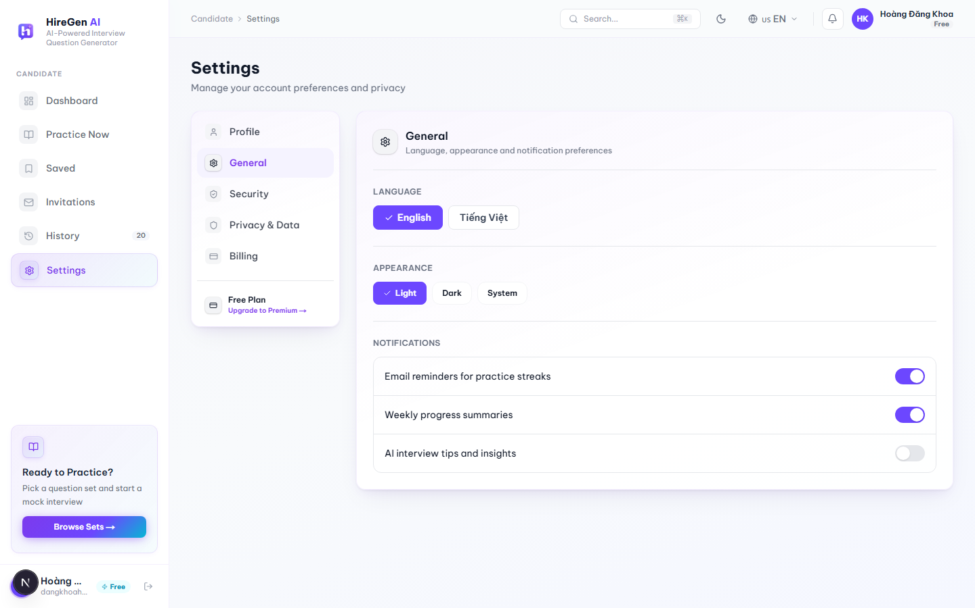
Figure 3.2.2.13. Settings, General tab.

3.2.2.13 Settings — General

Function trigger:
Settings → General tab (route: /jobseeker/settings?tab=general).
Function description:
General app preferences, not tied to any particular candidate data.
Pre-condition:
- Candidate is authenticated.
Function detail:
- Language can be switched between English and Tiếng Việt, and takes effect immediately across the app.
- Appearance can be set to Light, Dark or System.
- Notification toggles cover practice-reminder emails, weekly progress summaries, and AI interview tips.
- Which Settings tab is active is kept in the URL's `tab` query parameter, so a refresh or a shared link lands on the same tab.

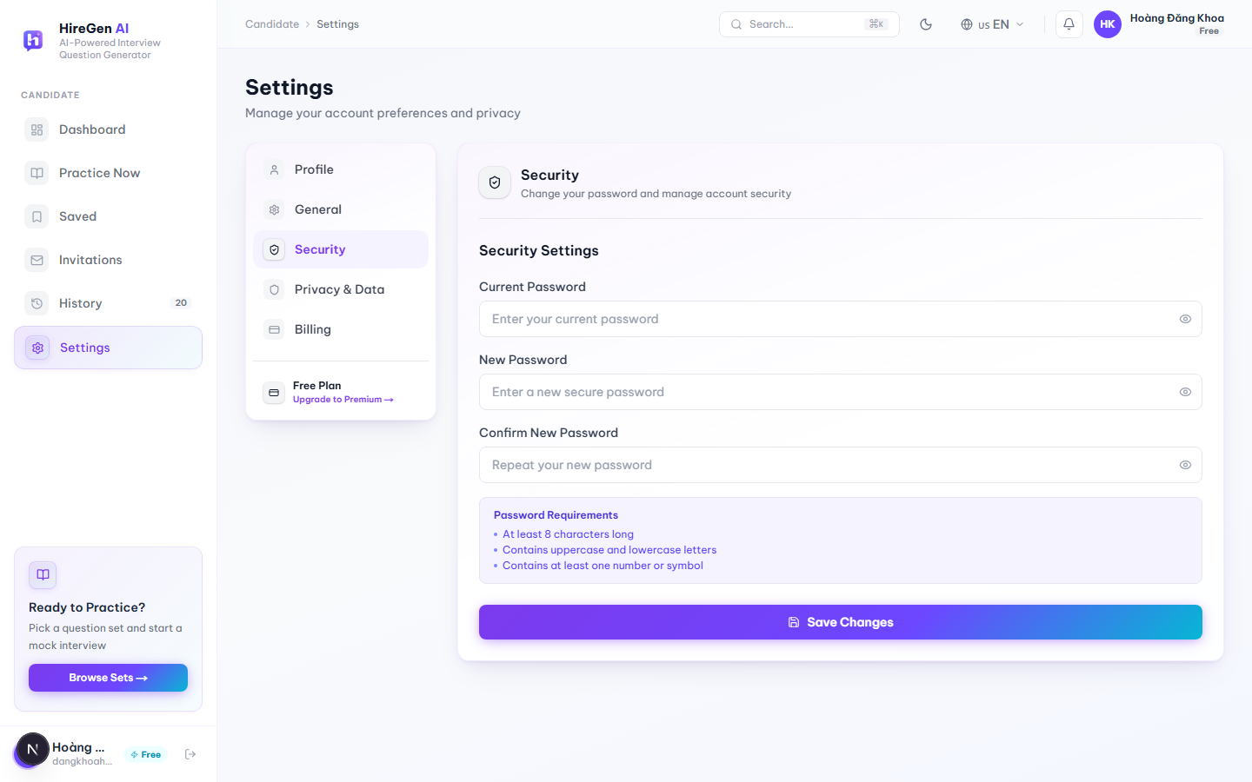
Figure 3.2.2.14. Settings, Security tab.

3.2.2.14 Settings — Security

Function trigger:
Settings → Security tab.
Function description:
Where a candidate changes their account password.
Pre-condition:
- Candidate is authenticated and knows their current password.
Function detail:
- The form has Current Password, New Password and Confirm New Password, each with a show/hide toggle.
- Password rules are shown right below the fields: at least 8 characters, upper- and lower-case letters, and at least one number or symbol.
- “Save Changes” sends the update to the backend.

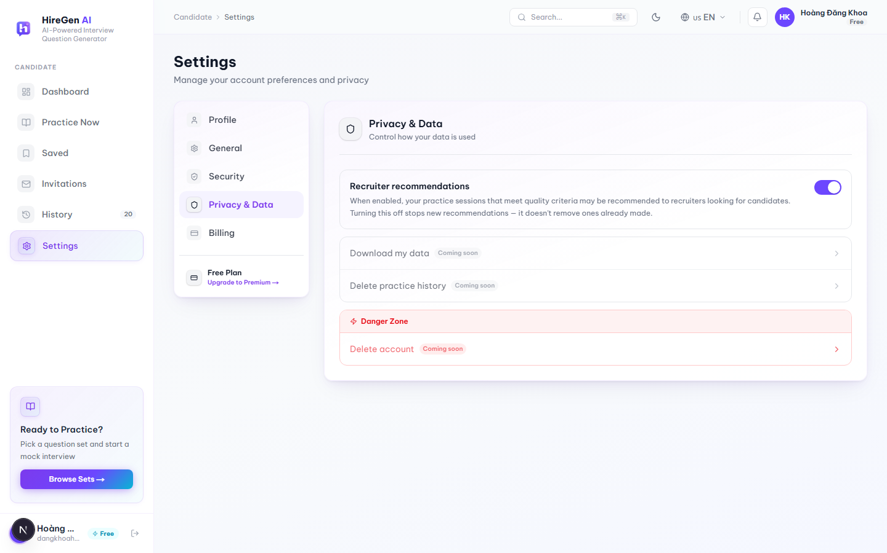
Figure 3.2.2.15. Settings, Privacy & Data tab.

3.2.2.15 Settings — Privacy & Data

Function trigger:
Settings → Privacy & Data tab.
Function description:
Controls what recruiters can see, plus a preview of some data-control tools that aren't live yet.
Pre-condition:
- Candidate is authenticated.
Function detail:
- A “Recruiter recommendations” toggle: while it's on, practice sessions that meet certain quality criteria may be recommended to recruiters. Turning it off only stops future recommendations — it doesn't undo anything already sent.
- “Download my data”, “Delete practice history” and “Delete account” (the last one sits in a red Danger Zone block) are all on the page but disabled, each labeled “Coming soon.”

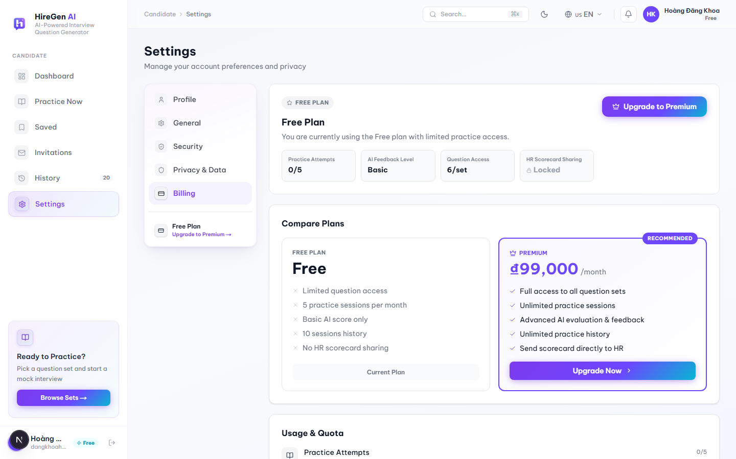
Figure 3.2.2.16. Settings, Billing tab, with real Free-plan quotas and the current Premium price.

3.2.2.16 Settings — Billing & Subscription

Function trigger:
Settings → Billing tab, or “Upgrade Premium” from the sidebar, Dashboard, or a locked practice question.
Function description:
Shows the candidate's current plan, how much of it they've used, and how it compares to Premium.
Pre-condition:
- Candidate is authenticated.
Function detail:
- The current-plan card shows a plan badge and four live numbers — on the Free plan these were Practice Attempts (0/5), AI Feedback Level (Basic), Question Access (6/set) and HR Scorecard Sharing (Locked).
- A Compare Plans section lines up Free (limited question access, 5 practice sessions a month, basic AI score only, 10 sessions of history, no HR scorecard sharing) against Premium (full access to all sets, unlimited sessions, advanced AI evaluation, unlimited history, scorecards can be sent to HR). Premium's price comes from the backend's live subscription plan rather than being hard-coded — 99,000 ₫/month at the time of testing.
- A Usage & Quota section repeats the same limits as progress bars, switching to a warning color once usage passes 80%.
- “Upgrade to Premium” / “Upgrade Now” opens the modal described in §3.2.2.17.

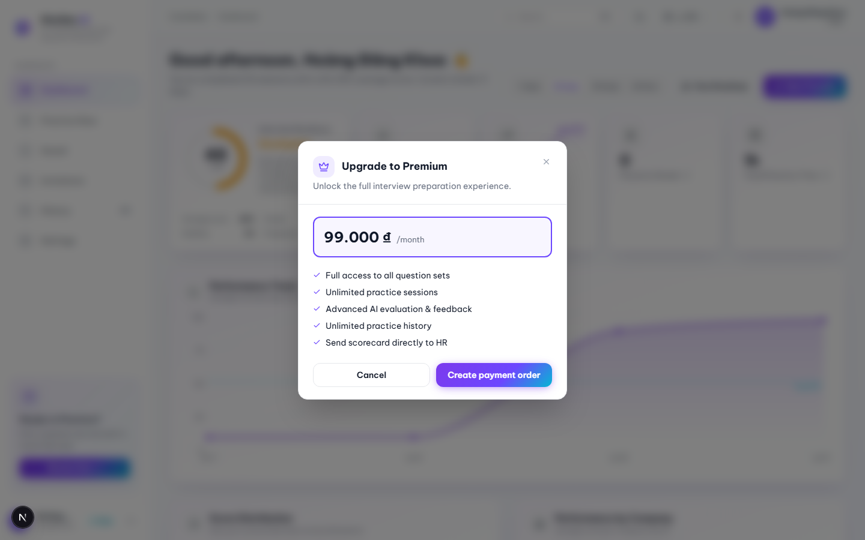
Figure 3.2.2.17. Upgrade to Premium modal, opened from the sidebar “Free” badge.

3.2.2.17 Upgrade to Premium Modal

Function trigger:
Candidate clicks the “Free” badge in the sidebar footer, “Upgrade to Premium” on the Billing tab, or the “Upgrade” button on a locked practice question.
Function description:
Lets a candidate start upgrading to Premium without leaving whatever page or session they were on.
Pre-condition:
- Candidate is currently on the Free plan.
Function detail:
- Shows the live monthly price pulled from the backend, plus a fixed list of Premium benefits: full access to all question sets, unlimited practice sessions, advanced AI evaluation, unlimited history, and sending scorecards directly to HR.
- “Create payment order” starts a QR-code payment flow and polls the order status until it's done; “Cancel” just closes the modal.
- Can be closed with the × button, the Esc key, or by clicking outside it.
- If it's opened from inside a practice session, a successful upgrade unlocks that session's locked questions right away — no reload needed — and a toast confirms it.

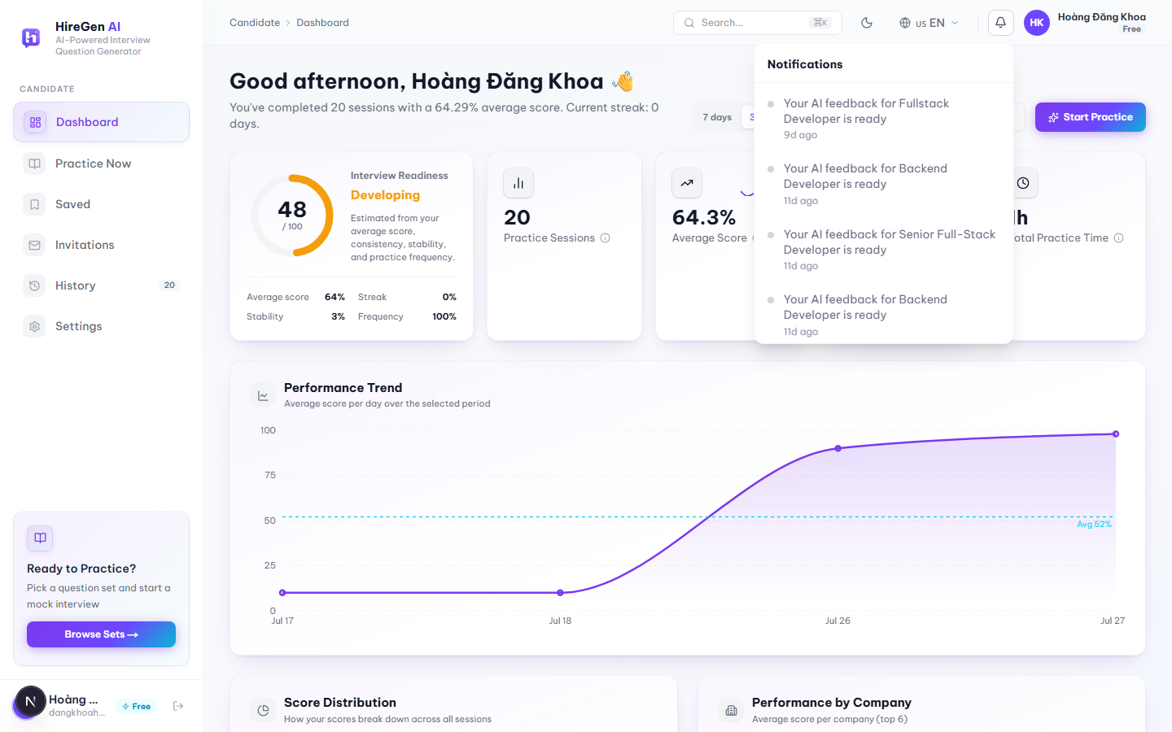
Figure 3.2.2.18. Notification bell dropdown.

3.2.2.18 Notification Bell

Function trigger:
Candidate clicks the bell icon in the top bar; it's available on every candidate page.
Function description:
A quick way to catch recent activity without going into History or Invitations directly.
Pre-condition:
- Candidate is authenticated.
Function detail:
- Notifications aren't a separate backend feed — they're put together on the client from two things: the 5 most recently completed practice sessions (“Your AI feedback for … is ready”) and any pending interview invitations.
- An unread-count badge sits on the bell icon; read/unread state is tracked per device in the browser and merged back in whenever the list loads.
- Clicking a notification jumps to the matching Feedback Result page or the Invitations page.
- The panel closes when the candidate clicks anywhere outside it.

3.2.3 Admin Interface

4. Non-Functional Requirements

4.1 External Interfaces

4.1.1 User Interface

HR/Admin UI part
- Layout Structure: The HR and Admin workspaces must use a uniform dashboard layout. This includes a fixed left-side navigation sidebar for quick screen switching and a top bar displaying the current user profile, company logo, and system notifications.
- Data Presentation: All data lists, user lists, and question repositories must be presented in structured tables. These tables must support basic sorting (by name, date, or status), keyword filtering, and pagination with a default view of 10 or 20 records per page to keep the screen clean.
- Responsive Design: Since HR Managers and Administrators work primarily on computers, the UI must be highly optimized for desktop and laptop screens with standard resolutions such as 1920x1080 and 1366x768. UI components should auto-align correctly without text overlapping if the window size changes.
- Asynchronous Loading Indicators: Because the AI question generation process runs in the background and takes time, the UI must display a clear progress bar or loading spinner on the generation screen. This lets the user know the system is still working and prevents them from clicking the submit button multiple times.

Candidate UI part
- Layout Structure:The candidate-facing interface must use a clean, content-first layout without a sidebar. A fixed top navigation bar must be present on all authenticated candidate screens, containing links to Marketplace, Practice History, Bookmarks, and a User Profile dropdown with logout option. The top bar must remain visible at all times regardless of scroll position to ensure quick access to core navigation. When a Free-tier candidate has exhausted their monthly practice quota, a non-dismissible upgrade banner must be displayed directly below the top bar on all screens, prompting the candidate to upgrade their subscription plan with a direct link to the Subscription Plans screen.
- Marketplace and Card Design: The Marketplace screen must present published question sets as a responsive card grid (3 columns on desktop, 2 on tablet, 1 on mobile). Each card must clearly display the question set title, company name, difficulty badge (with text label: Intern / Junior / Senior), skill tag chips, question count, and a bookmark icon toggle. A search bar and filter panel (Company, Skill, Difficulty, Sort Order) must be visible above the card grid without requiring the candidate to scroll. The Sort Order dropdown must support at least three options: Newest, Most Attempted, and Highest Rated. The listing must support pagination with a default of 12 cards per page, and pagination controls must be displayed at the bottom of the grid. The active filter selections must be shown as removable chips above the grid so the candidate can clearly see and remove individual filters without resetting all criteria.
- Practice Session Interface: The Practice Session screen must present one question at a time in a distraction-free, full-content layout. A countdown timer must be displayed prominently at the top of the screen and must change visual weight (bold text) at 5 minutes remaining and show a warning banner at 1 minute remaining. A progress indicator (e.g. "Question 3 of 10") must always be visible. The answer input field must auto-expand to fit typed content and must have a minimum height of 120px. Previous and Next navigation buttons must allow the candidate to move between questions freely before final submission; previously typed answers must be preserved in the local session state when navigating between questions. If the candidate attempts to navigate away from the Practice Session screen (e.g. by clicking a navigation link or closing the tab), the system must display a confirmation dialog: "Your session is in progress. Leaving this page will not submit your answers. Are you sure?" to prevent accidental data loss. On mobile viewports, the Submit button must be sticky at the bottom of the screen and always visible without scrolling.
- Answer Submission Confirmation: After the candidate clicks "Submit All", the system must display a dedicated Answer Submission confirmation screen before triggering AI evaluation. This screen must show a clear summary of the session: the number of questions answered, the number of questions skipped, and the total question count. Two action buttons must be available: "Confirm Submit" to proceed and "Back to Review" to return to the practice session and revise answers. If the countdown timer reaches zero before the candidate manually submits, the system must auto-submit all currently entered answers without showing this confirmation screen and must immediately transition to the loading state.
- AI Feedback Result Display: The AI Feedback Result screen must display the overall session score prominently at the top using a large numeric format with a performance tier label (e.g. "7.4 / 10 — Good"). Per-question feedback must be presented as collapsible accordion components to avoid overwhelming the candidate with information at once. Each accordion item must show the question text, the candidate's submitted answer, AI score (0–10), a strengths list, a weaknesses list, and actionable improvement suggestions. A "Share with HR" button and a "View in History" button must be clearly accessible below the overall score card. While the AI evaluation is still processing after answer submission, this screen must display a full-page loading state with a spinner and the message "Generating your feedback…" until the evaluation result is ready. If AI evaluation fails, a clear error message must be shown with a retry option.
- Practice History Screen: The Practice History screen must display all of the candidate's past practice sessions in a paginated table with the following columns: Date, Question Set Name, Company, Overall Score, and Status (Submitted / Processing). The default sort order must be by date descending (most recent first). Each row must include a direct link to the corresponding AI Feedback Result screen for that session. The candidate must be able to filter the history list by date range, question set keyword, or score range using filter controls above the table. A "Processing…" badge must be shown in the Status column for sessions where AI evaluation is still in progress. Pagination must default to 10 sessions per page.
- Bookmark List Screen: The Bookmark List screen must display all question sets the candidate has saved, presented in the same card grid format as the Marketplace (3 columns on desktop, 2 on tablet, 1 on mobile) to maintain visual consistency. Each card must include a filled bookmark icon that the candidate can click to remove the bookmark immediately via optimistic UI update. Each card must link directly to the corresponding Question Set Detail screen. If the candidate has no bookmarks, an empty state must be shown with the message "No bookmarks yet. Browse the Marketplace to find question sets you like." and a direct link to the Marketplace screen.
- Responsive Design: Since candidates frequently access the platform on both desktop and mobile devices, all candidate-facing screens must be fully functional and usable across desktop (≥ 1280px), tablet (768px – 1024px), and mobile (375px – 767px) viewports. The Marketplace card grid, Practice Session layout, and AI Feedback accordion must each adapt gracefully to the available screen width without horizontal scrolling or text overflow. All interactive elements (buttons, bookmark icons, accordion toggles, navigation links) must have a minimum touch target size of 44×44px to ensure comfortable usability on touchscreen devices. The platform must be fully functional on the latest stable versions of Google Chrome, Mozilla Firefox, and Microsoft Edge on both desktop and mobile.
- Loading and Empty States: All candidate screens that depend on API data (Marketplace, Practice History, Bookmarks, AI Feedback Result) must display a skeleton loader during data fetch rather than a blank screen. The AI Feedback Result screen must show a dedicated loading state with the message "Generating your feedback…" and a spinner while awaiting the AI evaluation response. The Answer Submission confirmation screen must display a loading overlay after the candidate clicks "Confirm Submit", blocking interaction while the system saves answers and triggers the AI evaluation job. All list screens (Practice History, Bookmarks, Marketplace with no results) must show a descriptive empty state message with a clear call-to-action button rather than an empty area.

4.1.2 Email Service Interface

4.1.3 Payment Service Interface

4.1.4 LLM Service Interface
IQGS integrates with the OpenAI GPT-4o model via the official OpenAI .NET SDK (runtime) and the OpenAI Python SDK (offline KB preparation). All API calls are authenticated using an API key stored in environment variables (never hard-coded).

Interface Property | Specification
Provider | OpenAI (api.openai.com)
Model | gpt-4o (Chat Completions API)
SDK – Runtime (.NET) | OpenAI .NET SDK (official) — used in ASP.NET Core service layer for online question generation and AI feedback
SDK – Offline (Python) | openai Python package — used in offline KB embedding scripts
Embedding Model | text-embedding-3-small (1536 dimensions) — used for both offline KB chunks and online JD query vectors
Authentication | OPENAI_API_KEY environment variable. Key must not be committed to source control.
Timeout | 60 seconds per API call. Hangfire job configured with 3 retries on timeout.
Rate Limiting | Batch embedding calls limited to 100 chunks/request. Exponential back-off on 429 (rate limit exceeded) errors.
Output Format | response_format: json_object enforced for all question generation and evaluation calls to guarantee structured JSON output.
Table 4.1.4: LLM Service Interface Specification

4.1.5 Vector Database Interface
IQGS uses pgvector — a PostgreSQL extension — as its vector store. Online retrieval is performed by the ASP.NET Core backend using Npgsql (PostgreSQL .NET driver). Offline ingestion uses psycopg2 (Python).

Interface Property | Specification
Database | PostgreSQL 15+ with pgvector extension enabled
Vector Column Type | vector(1536) — stores 1536-dimensional float32 embedding vectors
Index Type | HNSW index on the embedding column for approximate nearest-neighbour search (supports cosine distance)
Similarity Metric | Cosine distance (<=> operator). Query: SELECT *, 1 - (embedding <=> $queryVec) AS score FROM knowledge_base_chunks ORDER BY score DESC LIMIT $k;
Runtime Driver (.NET) | Npgsql 8.x with Npgsql.EntityFrameworkCore.PostgreSQL for ORM-level access; raw SQL for vector queries
Offline Driver (Python) | psycopg2 — used for bulk INSERT of chunk vectors during KB ingestion
Connection | Connection string from environment variable (DB_CONNECTION_STRING). TLS required for production.
Top-k Default | k=5, configurable via SystemConfig table
Table 4.1.5: Vector Database Interface Specification

4.1.6 File Storage Interface

4.2 Quality Attributes

4.2.1 Usability
- Required Training Time: * Normal Users (Candidates / Job Seekers): The client-side interface must be intuitive enough that a normal user can successfully browse question sets, start a mock practice session, and view their AI evaluation report within 5 minutes of their first access without any formal training.
  - Power Users (HR Managers / Administrators): An HR Recruiter or Admin must be able to master advanced operations (such as configuring RAG parameters, triggering background AI generations, uploading reference documents, or managing user accounts) within 20 minutes of reading a quick start guide or watching a short video walkthrough.
- Measurable Task Times: * A recruiter must be able to complete the setup form and trigger a new question generation session from a raw Job Description in less than 3 steps (clicks).
  - An administrator must be able to lookup any specific user profile or change account access roles within 10 seconds through the global user dashboard.
- Usability Standards: The layout structure, response alignments, form validation UI, and icon mappings across both the candidate portal and the administrative workspaces must strictly follow current Microsoft Fluent Design and Web GUI standards. This guarantees comfortable color contrasts, clear visual hierarchies, and a predictable user experience across all modern desktop web browsers.

5. Requirement Appendix [HIỀN + KHOA]

5.1 Business Rules [HIỀN]

ID | Rule Definition
BR-01 | Each email address must be unique across the entire system. A user cannot register with an email that already exists in the User table, regardless of role. Duplicate email triggers MSG_AUTH_REG_002.
BR-02 | A user must verify their email address before they can log in. Accounts with IsEmailVerified = false cannot obtain a JWT access token.
BR-03 | An HR Manager account is set to Pending status upon registration and requires explicit Administrator approval before login is permitted (mandatory per LI-02, Report 1).
BR-04 | Role-Based Access Control (RBAC) is enforced at the API level for all protected endpoints. A user can only access features permitted by their assigned role. Unauthorized access returns HTTP 403 Forbidden.
BR-05 | A password reset token is single-use and expires 15 minutes after generation. An email verification token is single-use and expires 24 hours after generation. Expired or used tokens are rejected.
BR-06 | An HR Manager may only trigger AI question generation if their active UserSubscription has RemainingGenerationQuota > 0. Each successful generation decrements quota by 1. Quota resets at each billing cycle renewal (CR-10).
BR-07 | A question set can only be published to the public marketplace if it contains at least 1 question. Empty sets cannot be published.
BR-08 | A question set's ownership is tied to the HR Manager account that created it. HR Managers may only view, edit, publish, or delete their own question sets. Administrators can moderate all question sets.
BR-09 | A Job Seeker on the Free tier can only view a limited subset of questions from any public question set (FullMarketplaceAccess = false). Full question access requires a premium subscription.
BR-10 | A Job Seeker may have at most one active (InProgress) PracticeSession per question set at any given time. A new session can only start after the previous is Submitted or its time limit has expired.
BR-11 | Practice session answers and AI feedback are stored for 90 days from the session submission date. After 90 days, raw AnswerText is archived by the Scheduled Cleanup Job. Session score and summary are retained permanently.
BR-12 | A Contact Request from a Job Seeker to an HR Manager is rate-limited to a maximum of 1 contact per (Candidate, Company) pair per 24-hour window.
BR-13 | A subscription upgrade payment Order expires 15 minutes after creation if payment is not confirmed. Only one PENDING Order is allowed per user at a time.
BR-14 | Subscription plans can only be upgraded to a higher tier. Plan downgrading takes effect at the end of the current billing cycle; user retains premium features until ExpiryDate.
BR-15 | Knowledge base documents must retain complete source metadata (Title, SourceType, Year, Source URL) as required by academic integrity policy per project topic section 3.3.
BR-16 | A Hangfire background job that fails is automatically retried up to 3 times with exponential backoff. After 3 failures, the job is marked FAILED, the failure is logged, and the user is notified.
BR-17 | All financial amounts in Orders are stored in Vietnamese Dong (VND). Per LI-06 (Report 1): only Payment Reference, Date, and tier are recorded; detailed billing breakdowns are out of scope.
BR-18 | The RAG Baseline Experiment (RAG vs. zero-shot vs. few-shot) is a mandatory research deliverable per project topic section 3.3. Must be triggered by an Administrator and produce an exportable evaluation report.

5.2 Common Requirements [HIỀN]

ID | Category | Requirement
CR-01 | Pagination | All list-type API endpoints (question sets, users, orders, practice history, contact requests) must support pagination. Default page size: 20 items. Maximum: 100 items. Response must include total count, current page, and total pages.
CR-02 | Date / Time | All dates stored in DB must use UTC timezone. All dates returned by the API must use ISO 8601 format (YYYY-MM-DDTHH:mm:ssZ). Frontend converts to ICT (UTC+7) for display.
CR-03 | Soft Delete | User accounts, question sets, knowledge base documents, and subscription plans are soft-deleted (Status = Deleted/Inactive) rather than physically removed. Physical deletion is not performed during the project lifecycle.
CR-04 | Audit Logging | All user actions that modify data (create, update, delete, publish, approve, ban) must be logged with: UserId, action type, target entity ID, and timestamp. Logs retained for at least 90 days.
CR-05 | Error Response Format | All API error responses must follow the standard format: { errorCode, message, timestamp, path }. HTTP status codes used correctly: 400, 401, 403, 404, 429, 500.
CR-06 | Language Support | Per LI-03 (Report 1): system supports Vietnamese and English for JD input, question generation, and AI evaluation. JDs submitted in Vietnamese must be processed correctly through the RAG pipeline.
CR-07 | File Upload Validation | All uploaded files must be validated for: (a) file extension whitelist (PDF, DOCX, TXT for documents; PNG, JPG for images), (b) MIME type matching declared extension, (c) file size per-type limits. Files failing validation are rejected before any storage operation.
CR-08 | Data Export Format | Question sets exported by HR Managers must be available in both PDF and DOCX formats, including: question text, type, difficulty, skill tags, and sample answer per question.
CR-09 | API Versioning | The IQGS REST API must use URL path versioning (e.g., /api/v1/...). Current version is v1. Adding a new version must not break existing v1 clients.
CR-10 | Subscription Quota Reset | At the start of each new billing cycle, the Scheduled Cleanup Job automatically resets RemainingGenerationQuota to the plan's full GenerationQuota for all active UserSubscription records.

5.3 System Messages List [KHOA]

# | Message Code | Message Type | Context (Trigger Condition) | Content (Display Text)
I | Authentication
1 | MSG_AUTH_01 | Toast Message | User successfully logs in with valid credentials. | "Login successful. Welcome back!"
2 | MSG_AUTH_02 | Inline (Red) | User submits incorrect email or password. | "Invalid email or password. Please try again."
3 | MSG_AUTH_03 | Toast Message | JWT signature expires during an active session. | "Session expired. Please log in again to continue."
4 | MSG_AUTH_04 | Toast Message | User successfully logs out of the platform. | "You have been successfully logged out."
II | Validation
5 | MSG_VAL_01 | Inline (Red) | A required input field is left empty upon submission. | "This field is required and cannot be left blank."
6 | MSG_VAL_02 | Inline (Red) | Input string exceeds the database character limit. | "Input exceeds the maximum allowed length."
7 | MSG_VAL_03 | Inline (Red) | Password fails complexity policies (length/characters). | "Password must contain at least 8 characters, including a number and a special character."
III | AI Generation
8 | MSG_GEN_01 | Toast Message | User triggers the AI question generation pipeline. | "AI generation started. Processing in the background..."
9 | MSG_GEN_02 | Toast Message | Hangfire async job completes successfully. | "Interview questions generated successfully!"
10 | MSG_GEN_03 | Toast Message | LLM API times out or fails to return a valid schema. | "AI generation failed or timed out. Please try again."
11 | MSG_GEN_04 | Toast Message | User quota for AI generation is depleted. | "AI generation quota exceeded. Please upgrade your plan."
IV | Question Set Management
12 | MSG_SET_01 | Toast Message | User successfully saves a new question set. | "Question set saved successfully."
13 | MSG_SET_02 | Toast Message | User deletes an existing question set. | "Question set deleted successfully."
14 | MSG_SET_03 | Toast Message | Set visibility is toggled to 'Published' (Marketplace). | "Question set is now published to the Marketplace."
V | Payment & Subscription
15 | MSG_PAY_01 | Toast Message | Financial gateway confirms successful transaction. | "Payment successful. Your subscription has been upgraded!"
16 | MSG_PAY_02 | Toast Message | Payment gateway rejects the transaction. | "Payment failed. Please check your billing information."
VI | File Uploads
17 | MSG_FILE_01 | Inline (Red) | User uploads an unsupported file extension. | "Unsupported format. Please upload PDF, DOCX, or TXT."
18 | MSG_FILE_02 | Inline (Red) | Uploaded file size exceeds the system payload limit. | "File size exceeds the 10MB maximum limit."
19 | MSG_FILE_03 | Toast Message | Document chunking and vectorization succeeds (RAG). | "File processed and indexed successfully."
VII | Practice Session (Candidate)
20 | MSG_PRAC_01 | Inline (Info) | Candidate starts the mock practice environment. | "Practice session started. The timer is now active."
21 | MSG_PRAC_02 | Toast Message | Candidate submits answers for AI evaluation. | "Answers submitted. Generating AI feedback..."
22 | MSG_PRAC_03 | Toast Message | AI feedback generation completes. | "Your AI evaluation report is ready to view!"
VIII | Admin Actions
23 | MSG_ADM_01 | Toast Message | Admin successfully updates a user's role. | "User role updated successfully."
24 | MSG_ADM_02 | Toast Message | Admin bans or suspends a user account. | "User account has been suspended."
25 | MSG_ADM_03 | Toast Message | Admin removes a violating public question set. | "Content flagged and removed from the marketplace."
26 | MSG_ADM_04 | Toast Message | Admin successfully saves new system configurations. | "System configurations updated successfully."

